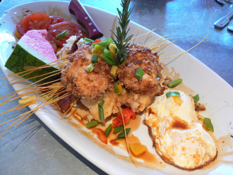

**Aurora School Coaching Menu**

**Choose from a variety of options. Mix and match to design a meal that appeals to you.**

**Note: All dishes are free (but chocolate or diet Pepsi will be accepted as payment.)☺**

**Desserts**

**Reflection –** **Through conversation and observation, reflect on student learning in your classroom.**

**Collaboration – Help you connect with other teachers in your own building or throughout the district.**

**Brainstorming Session – Collaboratively bounce innovative ideas off one another and plan how to implement them.**

**Listening and Support – Lend an open ear, brainstorm ideas for teaching a concept, or find research for a topic.**

**Main Entrees**

**Team Teaching Experience – After planning, cooperatively, teach a lesson together using best practices.**

**Demonstration Lesson – Demonstrate a lesson in your classroom or mine while you observe. Afterwards we reflect on what you saw.**

**Classroom Support – We pre-plan for when I observe your learning environment and we reflect on what I saw happening in your class. From this we set goals and further observation, and planning sessions directed by you. Can use video here.**

**Data Conversations – Collaboratively analyze formative assessment data to make instructional decisions individually or with your grade team.**

**Curriculum Support – Using a classroom support model, implement changes to subject instruction with the new/ unfamiliar curriculum and /or new teaching practice.**

**Appetizers**

**Gather Resources – Hunt for those hard to find lesson components, web pages, Smartboard activities, Web 2.0 activities and fresh ideas.**

**Co- planning – Through conversation, collaboratively plan a lesson or series of lessons to meet/use best practices.**

**Differentiated Support – Help design choice assignments or multi-leveled activities/ assessments or help with the implementation of proven resources or strategies from previous AISI projects.**

**Curriculum Support – Help with implementing new/unfamiliar curriculum through grade team planning sessions and resource building.**

**Technology Support – Help with making Smartboard activities or Web 2.0 individually or with your grade team, and integrating into lessons.**

Is there something that you are craving, but you don’t see it on the menu? ***Order it anyway.*** This chef is willing to cook up new creations as needed!!

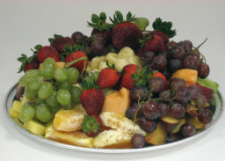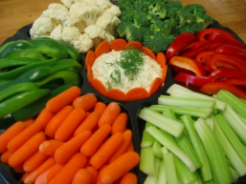

WARNING: The chef is **NOT** an expert, but does gather a wide range of ingredients and serving suggestions from other customers.

***Modified from Fargo Public Schools Coaching Menu